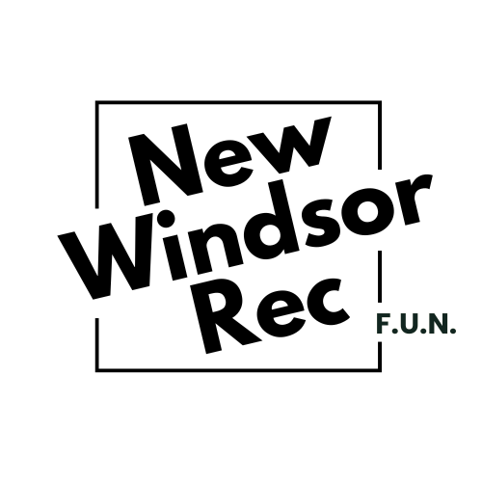
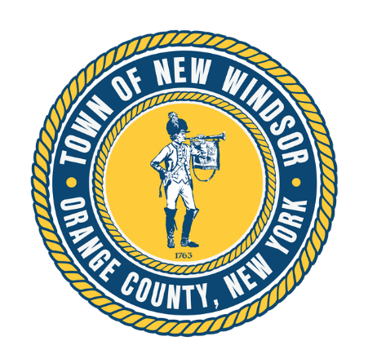
Town of New Windsor

Marasco Senior Center
555 Union Ave, New Windsor, NY 12553
Last updated: 2/3/26

Introduction & Mission
The Marasco Senior Center is the Town of New Windsor’s welcoming hub for adults 55+. It is a place for social connection, enrichment, health & wellness, and community support. The center offers classes, programs, trips, special events, and drop‑in activities that encourage independence, dignity, and overall well‑being for New Windsor older adults. Senior Services and Recreation staff can connect participants with local resources and information as needed.

Hours of Operation & Closures
Open: During programmed hours only. (See monthly calendar and www.nwrecisfun.com for specific program times).
Closures: The Marasco Center observes Town of New Windsor holiday closures and weather‑related closures.
Inclement Weather: Program cancellations and closures will be posted on nwrecisfun.com, the Recreation Department Facebook page, and via email/phone to registered participants.
Evenings/Weekends: Occasional evening/weekend programs may be offered.

Facility Use
The Marasco Center is dedicated to senior programming and events. Outside use (non‑Town, non‑senior) is limited and may require approval, insurance, and adherence to Town facility policies. Town and senior programs have priority.
Solicitation: The Center aims to be a commercial‑free environment. Sales presentations by for‑profit entities are not permitted. Educational talks without sales pressure may be approved at the Town’s discretion.
Donations: Due to limited storage, household item donations (e.g., clothing, books, furniture, food) are not accepted at the Center. Program sponsorships and monetary gifts may be coordinated through the Recreation Department.

Membership & Check‑In
Eligibility: Open to New Windsor seniors aged 55+. Caregivers may accompany members when needed and must also sign in as a program participant.
Registration: Create a MyRec account (nwrecisfun.com) or register in-person to sign required waivers.
Check‑In/Out: Please check in upon arrival and check out upon leaving.
Parking: Available in the Town Hall Complex.

Participation Guidelines
Members must be independent and oriented while at the Center. Town Recreation Staff cannot provide hands‑on personal care.
When applicable for personal care and best participation, a caregiver/companion should remain with the member at all times.
Behaviors that may limit participation include wandering, unmanaged incontinence, inability to self‑toilet or self‑feed, aggressive or disrespectful behavior, intoxication, chronic contagious illness, hygiene concerns, or unsafe mobility device use.
If guidelines are not followed, suspension from the senior center may occur.

Health & Safety
Illness: Stay home if you are sick or have a fever.
Tobacco/Vaping: Town facilities are tobacco‑ and vape‑free.
Alcohol/Drugs: Not permitted at Town facilities.
Weapons are prohibited.
No animals or pets are permitted.

Emergencies
Staff will call Town of New Windsor Police at 845-565-7000 or 911 when necessary. Current emergency contacts will be kept on file upon registration and participants are responsible for any future updates. Incidents are documented per Town policy.

Respectful Conduct & Exclusion Policy
New Windsor enforces zero tolerance for harassment, threats, or violence in public buildings. Actions that may lead to removal or suspension include property damage, harassment, obscene language, intimidation, illegal substances, dangerous objects, discriminatory speech, or unauthorized physical contact.

Food & Luncheons
The Town offers special luncheons for New Windsor residents throughout the year as well as other luncheons, events, and meetings sponsored by the New Windsor Senior Club. Advance registration is required. Fees may be associated with luncheon participation. Always check in advance.
Light refreshments may be provided during select programs. Participants may bring their own food into the center for day-of consumption. No food can be stored on site or overnight.
Only staff may access kitchen areas. Some parts of kitchen areas may be designated as common space (ie: for coffee service).

Fitness, Classes & Social Activities
Weekly offerings include movement/fitness, arts & crafts, games, cards, movies, and guest speakers.
Schedules are published on the Senior Center Calendar and Marasco Senior Center program pages on nwrecisfun.com.
Currently, all activities led by a Recreation staff member are free of charge.
Any classes led by an instructor (ex: Darlene, Kristina, or Paula) are offered with a $5.00 donation.

Town Bus Trips
The Recreation Department, in addition to the New Windsor Senior Club, offers occasional day trips and seasonal outings, departing from the Marasco Center.
Registration, departure times, fees, and refund policies are posted with each trip.
Town bus trips are not emergency medical transport. Riders must be able to embark/disembark independently.

Volunteering & Presenting
Seniors and partners who wish to volunteer, lead an activity, or present an educational session should contact the Recreation Department.

Compliments, Concerns, & Suggestions
Feedback is welcome. Speak with Center staff or email recoffice@newwindsor-ny.gov.

Photo/Media Notice
Programs may be photographed or recorded for Town communications. If you prefer not to be photographed, please inform staff.

Holiday & Observance Closures
The Center generally follows Town Hall closures.

Waivers & Forms
Program waivers are completed through MyRec during registration. Additional forms may be required.

Quick Links
Programs & Memberships: nwrecisfun.com → Seniors → Marasco Senior Center
Contact: (845) 565‑7750
Website: www.nwrecisfun.com

